Q2

Cameraman.tif

(a)

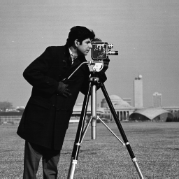

(b) Structural information:

shape, (256, 256)

ndim, 2

size, 65536

min value, 7

max value, 253

dtype, dtype('uint8')

(c)

f[100,100] = 9

Flowers-05.tif

(a)

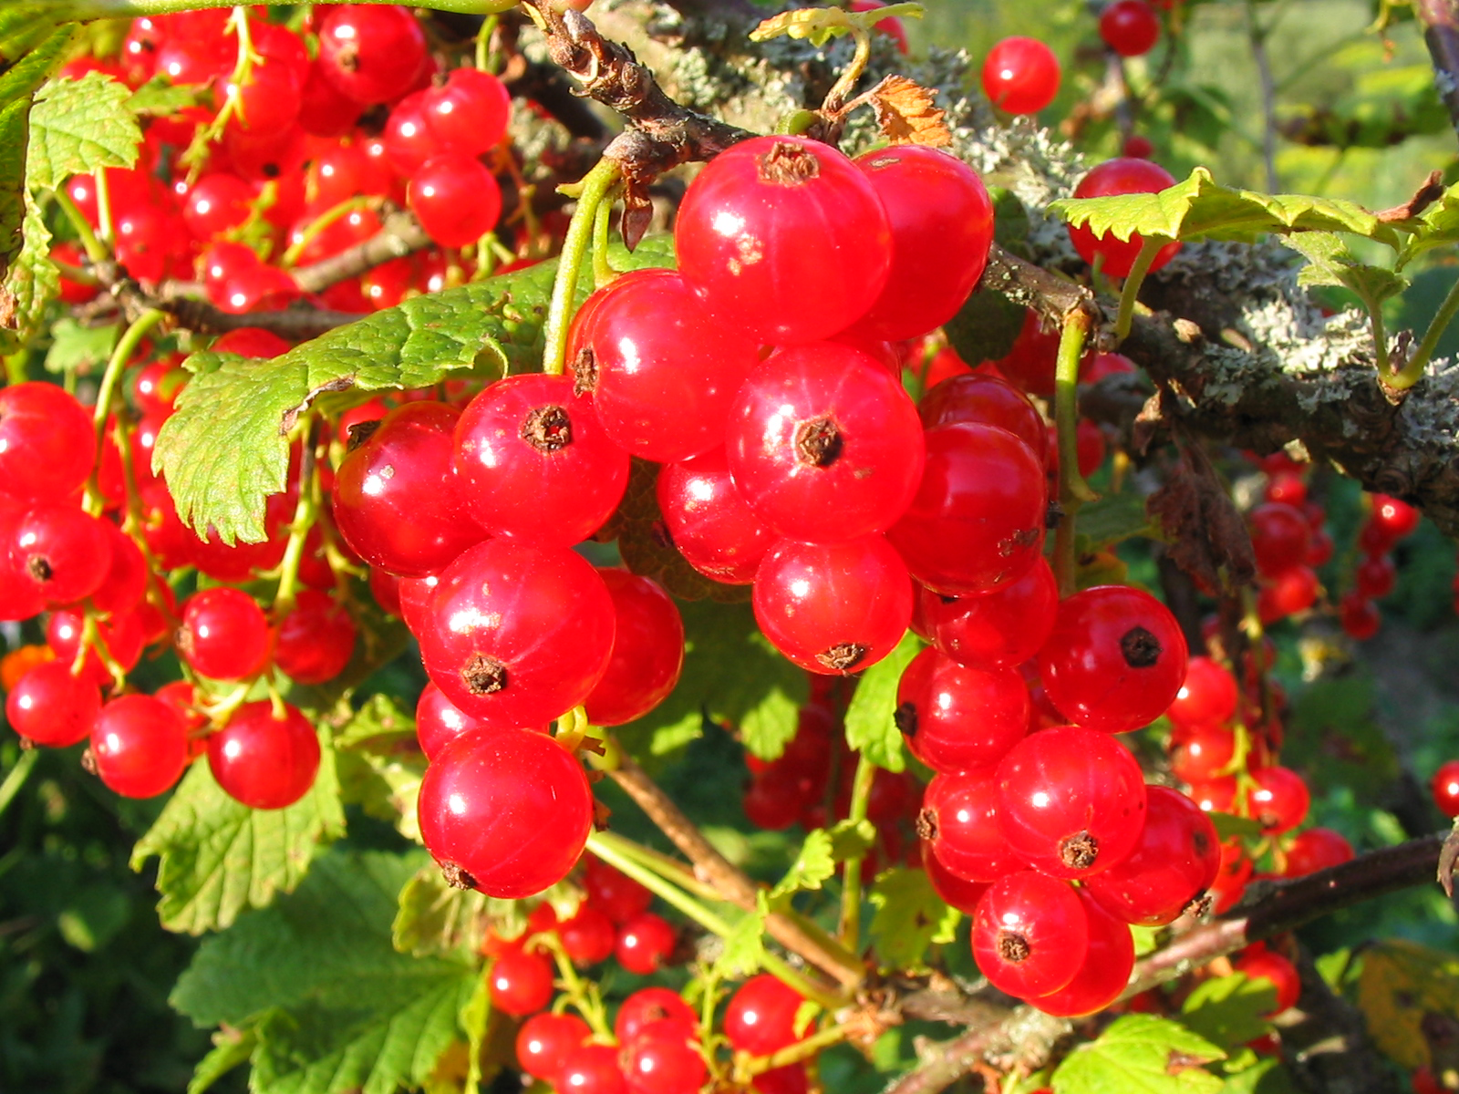

(b)Structural information:

shape, (1200, 1600, 3)

ndim, 3

size, 5760000

min value, 0

max value, 255

dtype, dtype('uint8')

(c)

array([220, 221, 67], dtype=uint8)

Q3

Converted cameraman.tif

(a)



(b)

shape, (256, 256)

ndim, 2

size, 65536

min value, 7

max value, 253

dtype, dtype('uint8')

Converted flower-05.tif

(a)

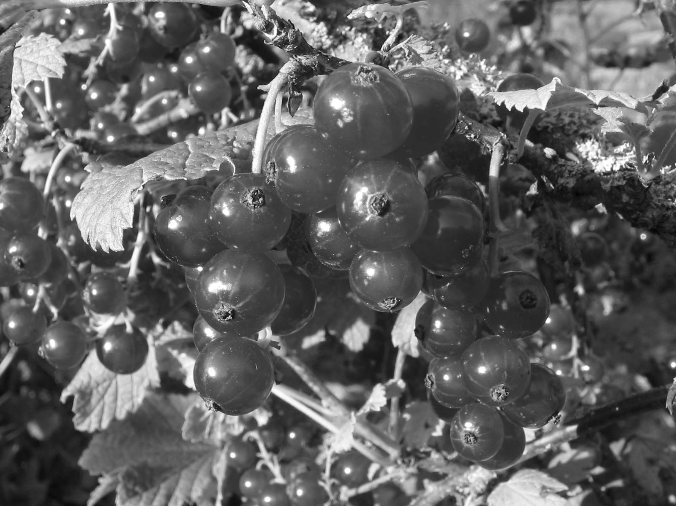

(b)

shape, (1200, 1600)

ndim, 2

size, 1920000

min value, 0.015686274509803921

max value, 1.0

dtype, dtype('float64')

code:

import numpy

import scipy

import pandas

import matplotlib

from skimage.viewer import ImageViewer as IV

import skimage.io as io

import exifread

from skimage.color import rgb2gray

c = io.imread('/Users/liutongyang/Dropbox/2016GU/imagepro/1/cameraman.tif')

f = io.imread('/Users/liutongyang/Dropbox/2016GU/imagepro/1/flowers-05.tif')

viewer = IV(c)

viewer.show()

c.shape

c.ndim

c.size

c.min()

c.max()

c.dtype

viewer = IV(f)

viewer.show()

f.shape

f.ndim

f.size

f.min()

f.max()

f.dtype

graycmat = rgb2gray(c)

grayc = IV(graycmat)

grayc.show()

graycmat.shape

graycmat.ndim

graycmat.size

graycmat.min()

graycmat.max()

graycmat.dtype

grayfmat = rgb2gray(f)

grayf = IV(grayfmat)

grayf.show()

grayfmat.shape

grayfmat.ndim

grayfmat.size

grayfmat.min()

grayfmat.max()

grayfmat.dtype